Unit 2 Test Review Geometry

Determine the converse, inverse, and contrapositive of the conditional statements. Indicate whether each statement is true or false.

1. Conditional statement: If R is the midpoint of , then . Go07an_0202read_02

Converse:

Inverse:

Contrapositive:

**Tell whether each conclusion uses inductive or deductive reasoning.**

2. A sign in the cafeteria says that a car wash is being held on the last Saturday of May. Tomorrow is the last Saturday of May, so Justin concludes that the car wash is tomorrow.

3. So far, at the beginning of every Latin class, the teacher has had students review vocabulary. Latin class is about to start, and Jerry assumes that they will first review vocabulary.

**Write the final statement and determine whether each conjecture is valid by the Law of Detachment or Syllogism.**

4. Given: If you ride the Titan roller coaster in Arlington, Texas, then you will drop 255 feet.

If you drop 255 feet, then you will be scared.

\_\_\_\_\_\_\_\_\_\_\_\_\_\_\_\_\_\_\_\_\_\_\_\_\_\_\_\_\_\_\_\_\_\_\_\_\_\_\_\_\_\_\_\_\_\_\_\_\_\_\_\_\_\_\_\_\_\_\_\_\_\_\_\_

5. Given: A segment that is a diameter of a circle has endpoints on the circle.

 has endpoints on a circle.

\_\_\_\_\_\_\_\_\_\_\_\_\_\_\_\_\_\_\_\_\_\_\_\_\_\_\_\_\_\_\_\_\_\_\_\_\_\_\_\_\_\_\_\_\_\_\_\_\_\_\_\_\_\_\_\_\_\_\_\_\_\_\_\_

Write a biconditional from each given conditional and converse.

6. Conditional: If two angles share a side, then they are adjacent.

Converse: If two angles are adjacent, then they share a side.

Biconditional:

**Identify the property that justifies each statement.**

7. If ABC  DEF, then DEF  ABC. 8. 1  2 and 2  3, so 1  3. 9. 

Write a justification for each step.

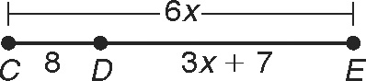

10. CE  CD  DE

6x  8  (3x  7)

6x  15  3x

3x  15

x  5

Write a justification for each step.

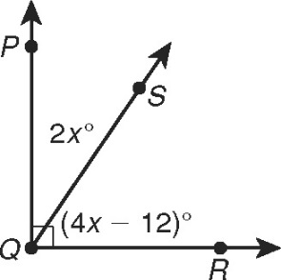11. mPQR  mPQS  mSQR

90  2x  (4x  12)

90  6x  12

102  6x

17  x

**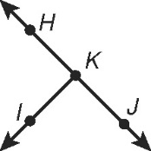**12. Given: HKJ is a straight angle,  bisects HKJ.

Prove: IKJ is a right angle.

|  |  |
| --- | --- |
| **Statements** | **Reasons** |
| 1. a. | 1. Given |
| 2. mHKJ  180 | 2. b. |
| 3. c. | 3. Given |
| 4. IKJ  IKH | 4. Def. of  bisector |
| 5. mIKJ  mIKH | 5. Def. of  |
| 6. d. | 6.  Add. Post. |
| 7. 2mIKJ  180 | 7. e. Subst. (Steps \_\_\_\_\_\_\_) |
| 8. mIKJ  90 | 8. Div. Prop. of  |
| 9. IKJ is a right angle. | 9. f. |

**Find each angle measure.**

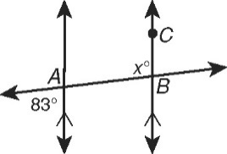 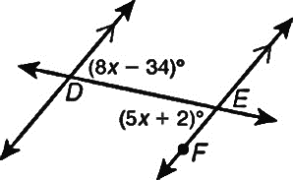

13. mABC \_\_\_\_\_\_\_\_\_\_\_\_\_\_\_\_\_\_\_\_\_\_\_ 14. mDEF \_\_\_\_\_\_\_\_\_\_\_\_\_\_\_\_\_\_\_\_\_\_\_

Give two examples of each kind of angle pair in the figure.

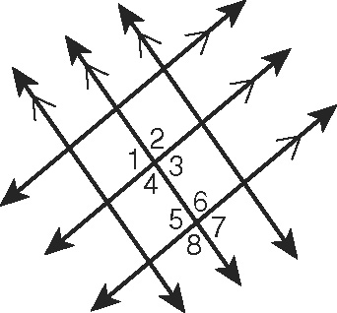15. alternate interior angles \_\_\_\_\_\_\_\_\_\_\_\_\_\_\_\_\_\_\_\_\_\_\_\_\_\_

16. alternate exterior angles \_\_\_\_\_\_\_\_\_\_\_\_\_\_\_\_\_\_\_\_\_\_\_\_\_\_

17. same-side interior angles \_\_\_\_\_\_\_\_\_\_\_\_\_\_\_\_\_\_\_\_\_\_\_\_\_

18. Corresponding angles \_\_\_\_\_\_\_\_\_\_\_\_\_\_\_\_\_\_\_\_\_\_\_\_\_

**19. Given , m∠1 = 100°, and m∠2 = 61°, find the measures of all the numbered angles.**

m∠3 = \_\_\_\_\_, m∠4 = \_\_\_\_\_\_, m∠5 = \_\_\_\_\_\_, m∠6 = \_\_\_\_\_\_

11

10

m∠7 = \_\_\_\_\_, m∠8 = \_\_\_\_\_\_, m∠9 = \_\_\_\_\_\_

12

m∠10 = \_\_\_\_\_, m∠11 = \_\_\_\_\_\_, m∠12 = \_\_\_\_\_\_

What is the relationship between ∠1 and ∠4?

What is the relationship between ∠2 and ∠8?

What is the relationship between ∠6 and ∠9?

Complete the two-column proof to show that same-side exterior angles are supplementary.

20. Given: p || q

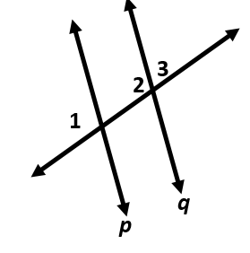 Prove: m1  m3  180

|  |  |
| --- | --- |
| **Statements** | **Reasons** |
| 1. p || q | 1. Given |
| 2. a. \_\_\_\_\_\_\_\_\_\_\_\_\_\_\_\_\_\_\_\_\_\_\_ | 2. Lin. Pair Thm. |
| 3. 1  2 | 3. b. \_\_\_\_\_\_\_\_\_\_\_\_\_\_\_\_\_\_\_\_\_\_\_ |
| 4. c. \_\_\_\_\_\_\_\_\_\_\_\_\_\_\_\_\_\_\_\_\_\_\_ | 4. Def. of  |
| 5. d. \_\_\_\_\_\_\_\_\_\_\_\_\_\_\_\_\_\_\_\_\_\_\_ | 5. e. \_\_\_\_\_\_\_\_\_\_\_\_\_\_\_\_\_\_\_\_\_\_\_ |

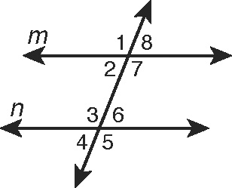

Use the figure for Exercises 21–24. Tell whether lines **m** and **n**   
must be parallel from the given information. If they are, state   
your reasoning. (**Hint:** The angle measures may change for   
each exercise, and the figure is for reference only.)

21. 7  3 22. m3  (15x  22)°, m1  (19x  10), x  8

23. 7  6 24. m2  (5x  3)°, m3  (8x  5), x  14

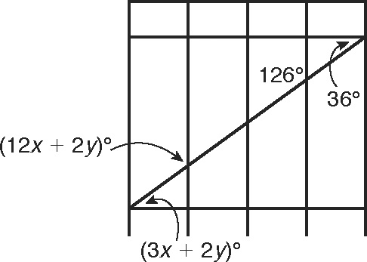

25. In the diagram of the gate, the horizontal bars   
are parallel and the vertical bars are parallel.   
Find x and y.

\_\_\_\_\_\_\_\_\_\_\_\_\_\_\_\_\_\_\_\_\_\_\_\_\_\_\_\_\_\_\_\_\_\_\_\_\_\_\_\_\_\_\_\_\_

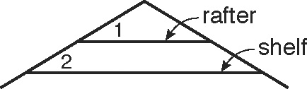26. A bedroom has sloping ceilings as shown. Marcel is hanging   
a shelf below a rafter. If m1  (8x  1), m2  (6x  7),   
and x  4, show that the shelf is parallel to the rafter above it.

\_\_\_\_\_\_\_\_\_\_\_\_\_\_\_\_\_\_\_\_\_\_\_\_\_\_\_\_\_\_\_\_\_\_\_\_\_\_\_\_\_\_\_\_\_

Name the shortest segment from the point to the line and write an inequality for **x**.

27.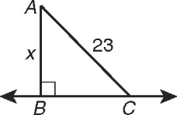 28. 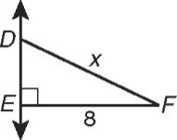

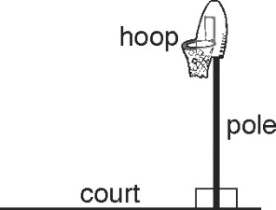

Use the drawing of a basketball goal.  
In each exercise, justify Esperanza’s conclusion with one   
of the completed theorems from Exercises 29-30.

29. Esperanza knows that the basketball pole intersects the   
court to form a linear pair of angles that are congruent.   
She concludes that the pole and the court are perpendicular. \_\_\_\_\_\_\_\_\_\_\_\_\_\_\_\_\_\_\_\_\_\_

30. Esperanza knows that the hoop and the court are both   
perpendicular to the pole. She concludes that the hoop   
and the court are parallel to each other. \_\_\_\_\_\_\_\_\_\_\_\_\_\_\_\_\_\_\_\_\_\_

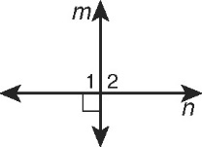Complete a flow chart proof.

31. Given: m  n

Prove: 1 and 2 are a linear pair of congruent angles.