9.14 HW Triangle Coordinate Proofs Name: _________________________
Directions: Prove each shape is a right triangle by showing that the triangle has a right angle.
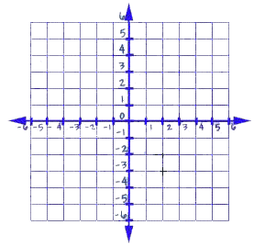
1) Given: A(1, 1), B(4, 4), & C(5, –3)
Prove : ABC is a right triangle

2) Given: D(–2, 2), E(1, 4), & F(3, 1)
Prove: DEF is a right triangle

Directions: If $\overline{AC}$ is the hypotenuse of a right triangle, find two ordered pairs that could represent Point B in ∆ABC.

3) A(2, 3) and C(–3, –2) 4) A(–1, –1) & C(0, 2)

Directions: Prove each triangle is a right triangle by using Pythagorean Theorem.

5) A(0, 1), B(5, 2), & C(3, 4) 6) A(–2, –3), B(–1, 1), & C(3, 0)

Directions: Complete each proof.

7) Prove that D(–2, –2), E(5, –1), F(1, 2) is an isosceles right triangle.

8) Prove that M(–2, 4), N(4, 4), P(–2, –4) is a scalene right triangle.

