9.15 HW Parallelogram and Rectangle Proofs Name: _______________________

Directions: Identify the Quadrilateral PQRS, with the given points. SHOW ALL WORK!!!
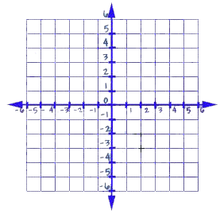

1) Plot Quadrilateral PQRS: P (–1, 2) Q (2, 4) R (3, –1) S (0, –3)

2) What shape does it appear to be?

3) What do you have to show?

4) Check off all that apply:

_____opposite sides parallel

_____consecutive sides perpendicular
_____four congruent sides

_____Only 1 pair of opposite sides parallel

_____ Congruent legs

_____ two pairs of congruent sides (consecutive)

5) Which shape is it? ____________________

6) Why?

7) Plot Quadrilateral ABCD: A(0, 2), B(6, –2), C(4, –5), D(–2, –1)

8) What shape does it appear to be?

9) What do you have to show?

10) Check off all that apply:

_____opposite sides parallel

_____consecutive sides perpendicular
_____four congruent sides

_____Only 1 pair of opposite sides parallel

_____ Congruent legs

_____ two pairs of congruent sides (consecutive)

11) Which shape is it? ____________________

12) Why?

Directions: State the ordered pair that is needed to make the following figure.
13) PQRS will be a parallelogram; 14) DEFG will be a rectangle;
P(2, 2), Q(5, 1), S(–1, –2) D(0, 3), E(2, –1), F(0, –2)

Directions: Solve each problem.
15) Prove that ABCD is a parallelogram when A(–2, 3), B(4, 3), C(2, –2), & D(–4, –2)

16) Prove that RSTV is a rectangle when R(1, 1), S(2, 4), T(5, 6), and V(4, 3)

17) Determine whether ABCD is a parallelogram, a rectangle, or neither
when A(1, 1), B(2, 4), C(5, 6), & D(4, 3).

