Unit 10 Study Guide Name:

In a bowl of marbles, there are 10 red ones, 6 green ones, and 8 blue ones.

- If a marble is chosen at random from the bowl, find P(red one or a blue one)?

- If two marbles are chosen at random with replacement, find P(red and a blue)?

- If two marbles are chosen at random without replacement, find P(they are both red)?

+ | 1 | 2 | 3 | 4 | 5 | 6
1
2
3
4
5
6

A person rolls two dice, one after the other.

- P(even sum) or P(sum of 9)

- P(odd sum) or P(sum less than 5)

- What is the probability that the sum of two rolls
is an even number given at least one of the rolls is a 4?

A card is chosen from a standard deck of cards. The drawer is looking for clubs and face cards.

 | Club | Not a Club
Face card | 3 | 9
Not a face card | 10 | 30

- Find P(Club)

- Find P(Club | Not a Face Card)

- Find P(Club Face Card)

- Find P(Not a Club Not a Face Card)

- Are the events Club and Not a Face Card Independent of each other?

- In a Coordinate Algebra class, 22 students were male and 10 students were female. Out of those students, 11 of the guys and 4 of the girls passed the EOCT. If a person is chosen at random from the class, what is the probability of choosing a girl or a person that did NOT pass the EOCT?
 | Pass | Not Pass
Male
Female

Directions: Use the given sets to answer each question.

U = {3, 7, 11, 12, 15, 18, 20, 22, 24, 25} A = {11, 18, 24, 25}

B = {prime numbers} C = {3, 7, 12, 18, 20, 24}

13) $A∪C$ 14) $B∩C$ 15) $\left(A∩C\right)∪B$
16) ${\left(B∪C\right)}^{'}$ 17) B – C 18) C – B

In a survey of 450 people, 200 of whom are female, it was found that 225 prefer chocolate ice cream including 99 males. Use this information to complete the table below.
 | Males | Females
Vanilla
Chocolate
 |  |  | 450

19. The person likes chocolate.

20. The person like vanilla, given they are male.

21. The person likes vanilla or is a female.

22. Are being a male and liking chocolate independent events?

Directions: Shade the regions that represent the following sets.
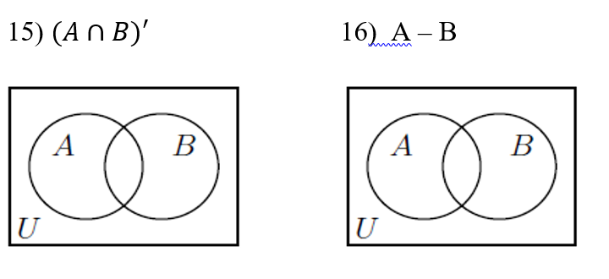

25. What is the P(getting a pair of Ace’s from a deck of cards l one Ace)?

26. What is the probability of flipping a coin three times and getting heads all three times?

27. What is the probability of getting a sum of 4 on a pair of dices and selecting the letter
G from GABEL?

